**The Other Alex**

Devin Kadillak, Alex Malott, Alex Shellum, Aaron Thompson, Lucas Wilson

**Requirements**

1. User should be able to register an account using email, nickname, and password.
2. User should be able to create a new match but must wait for another player (bot or invited player) to join before playing.
3. The user should be able to invite one or more people to join their game.
4. The first user to accept the invitation to a game should be chosen to join the game.
5. User should be able to reject invitation, and the sender should be notified of either acceptance or rejection.
6. User should be able to play multiple games at once.
7. Users should also be able to unregister their account.
8. Requirement: System should store user match history information (see below) Could wrap this and 10 into player information.
9. Requirement: system should store information about games like: players, start and end dates and times, and whether the game ended in a loss, win, or withdraw.
10. System should keep info about abandoned games.
11. Registered users should be able to view the match history of other players.
12. While playing, the rules of the game must be followed.
13. The invite invitation remains open only until another player joins.
14. The first player to move is the more experienced; if experience is equal, first move goes to the creator of the match.
15. The system knows whose turn it is.
16. The players can only make a legal move during their turn.
17. The state of matches should be saved after user logs out, so that the user can come back to a game and play whenever they want. The other player should be able to make moves while the other player is logged out.
18. Users should be informed of if they won or lost, according to the rules of the game.

**Extra Requirements**

1. Users should be able to play against and AI “bot” that can determine what moves to make.
2. Users should be able to make a tournament that other users can join.

**Use Case Diagram**

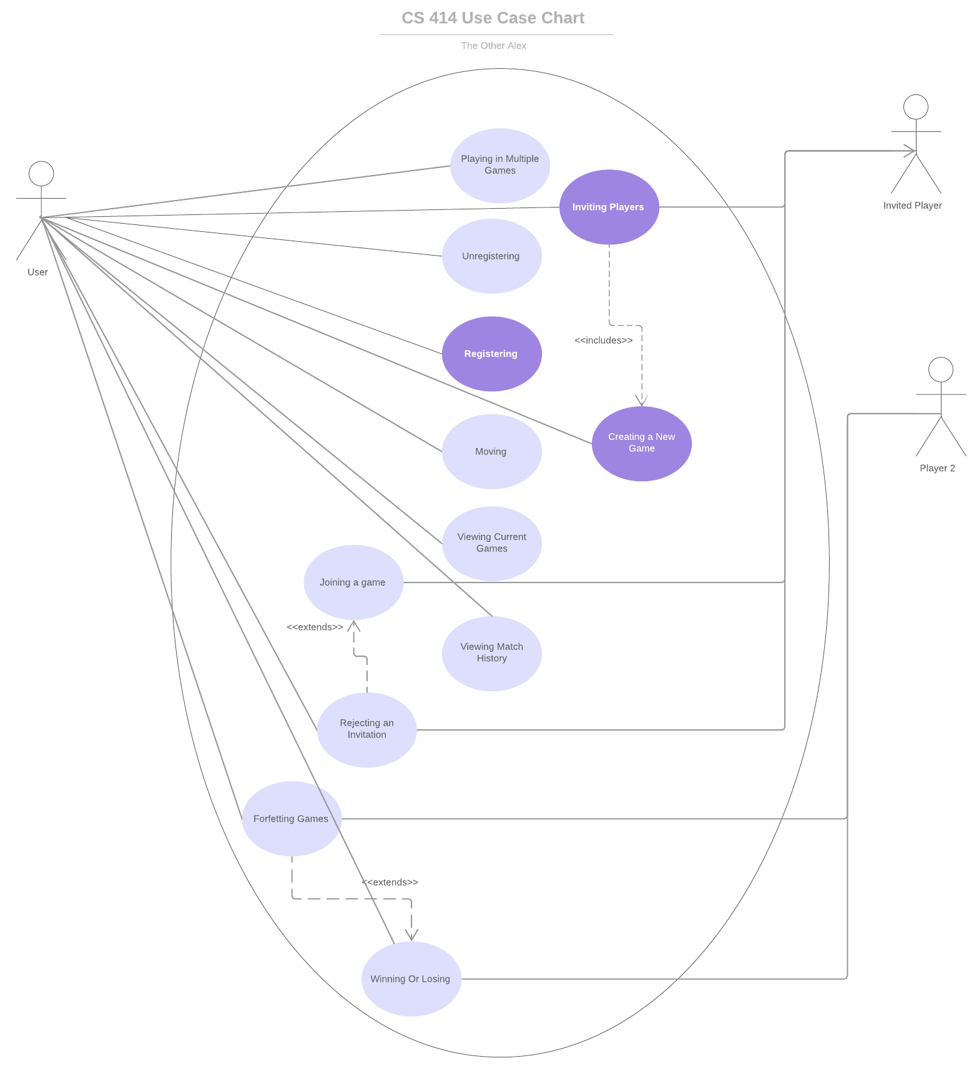

**Use Cases**

|  |  |
| --- | --- |
| Use case id: | EU-1 |
| Use case name: | Registering |
| Overview: | Allowing user to set up an account. |
| Type: | primary |
| Actors: | User {Initiator} {primary} |
| Secondary actors: | N/A |
| Properties: | Performance: N/A  Security: N/A  Other: N/A |
| Pre-conditions: | The user should have a valid email address. |
| Main Flow: | 1) user should be prompted to enter email  2) user should be prompted to set up username and password  3) user should now be registered on the site |
| Subflows: | Break down of main flow steps |
| Alternative flows: | N/A |
| Post-conditions: | User should now have full access to the system. |
| Cross references: | N/A |

|  |  |
| --- | --- |
| Use case id: | EU-2 |
| Use case name: | Creating a New Game |
| Overview: | User should be able to initiate a new game. |
| Type: | primary |
| Actors: | User {Initiator} {primary} |
| Secondary actors: | Player 2 |
| Properties: | Performance: N/A  Security: N/A  Other: N/A |
| Pre-conditions: | The User and Player 2 must be registered in the system |
| Main Flow: | 1) User should be able to create a new game instance  2) User selects auto-forfeit time  3) User chooses whether to play against a human or a bot  4) User should not be able to play until Player 2 joins |
| Subflows: | Break down of main flow steps |
| Alternative flows: | N/A |
| Post-conditions: | A new game instance is created |
| Cross references: | N/A |

|  |  |
| --- | --- |
| Use case id: | EU-3 |
| Use case name: | Inviting players |
| Overview: | Allows User to invite one or more additional players to their game |
| Type: | Primary |
| Actors: | User {Initiator} {Primary} Invited Players {primary} |
| Secondary actors: | N/A |
| Properties: | Performance: N/A  Security: N/A  Other: N/A |
| Pre-conditions: | User has created a game instance |
| Main Flow: | 1) User provides a list of players to invite  2) Invited Players are notified they’ve been invited  3) An Invited Player joins the game  4) All outstanding invitations are revoked |
| Subflows: | N/A |
| Alternative flows: | Instead of step 3, the user who creates the invite chooses to cancel it. |
| Post-conditions: | An Invited Player is still in the game |
| Cross references: | EU-4 |

|  |  |
| --- | --- |
| Use case id: | EU-4 |
| Use case name: | Joining a game |
| Overview: | The first player to accept an invite joins the game |
| Type: | primary |
| Actors: | Invited Player {Initiator} {Primary} |
| Secondary actors: | User |
| Properties: | Performance: N/A  Security: N/A  Other: N/A |
| Pre-conditions: | A game instance has been created by User and invitations have been sent out |
| Main Flow: | 1) Invited Player receives the invitation to User’s game  2) Invited Player accepts invitation  3) Invited Player joins User’s game. |
| Subflows: | N/A |
| Alternative flows: | 1) The invitation has already been accepted by someone else. Post-condition: Invited Player is notified that the game is full |
| Post-conditions: | Invited Player joins User’s game |
| Cross references: | N/A |

|  |  |
| --- | --- |
| Use case id: | EU-5 |
| Use case name: | Rejecting an Invitation |
| Overview: | Invited Players should be able to reject an invitation. |
| Type: | primary |
| Actors: | Invited Player {Initiator} {Primary} User {Primary} |
| Secondary actors: | N/A |
| Properties: | Performance: N/A  Security: N/A  Other: N/A |
| Pre-conditions: | A game has been initiated by User and User has sent Invited Player an invitation. |
| Main Flow: | 1) Invited Player receives invitation from User.  2) Invited Player rejects invitation.  3) User is notified of Invited Player’s rejection. |
| Subflows: | N/A |
| Alternative flows: | N/A |
| Post-conditions: | Invited Player does not join User’s game, User’s invitation is still active to other players. User is notified of rejection. |
| Cross references: | N/A |

|  |  |
| --- | --- |
| Use case id: | EU-6 |
| Use case name: | Playing in Multiple Games |
| Overview: | Users should be able to be involved in multiple game instances at once |
| Type: | primary |
| Actors: | User {Initiator} {Primary} |
| Secondary actors: | Additional Players |
| Properties: | Performance: N/A  Security: N/A  Other: N/A |
| Pre-conditions: | User is registered |
| Main Flow: | 1) User initiates a game and invites players  2) User initiates more games and invites players |
| Subflows: | N/A |
| Alternative flows: | 1) User is invited to one or more games by additional players  2) User accepts invites  Post-Conditions: User is now a part of all games that they were the first to accept the invitation to. |
| Post-conditions: | User is playing in all game instances they initiated that additional players have accepted the invitations to. |
| Cross references: | EU-4 |

|  |  |
| --- | --- |
| Use case id: | EU-7 |
| Use case name: | Forfeiting games |
| Overview: | User should be able to leave games |
| Type: | primary |
| Actors: | User {Initiator} {Primary} Player 2 {Primary} |
| Secondary actors: | N/A |
| Properties: | Performance: N/A  Security: N/A  Other: N/A |
| Pre-conditions: | A game between User and Player 2 is in progress |
| Main Flow: | 1) User leaves an in-progress game  2) User loses game |
| Subflows: | N/A |
| Alternative flows: | N/A |
| Post-conditions: | Player 2 wins the game |
| Cross references: | N/A |

|  |  |
| --- | --- |
| Use case id: | EU-8 |
| Use case name: | Unregistering |
| Overview: | User should be able to unregister their account. |
| Type: | Primary |
| Actors: | User {Initiator} {Primary} |
| Secondary actors: | N/A |
| Properties: | Performance: N/A  Security: N/A  Other: N/A |
| Pre-conditions: | User should have an account. |
| Main Flow: | 1) User chooses to unregister their account  2) The user’s active games are forfeited |
| Subflows: | N/A |
| Alternative flows: | N/A |
| Post-conditions: | User’s account and information is deleted. |
| Cross references: | EU-10 EU-7 |

|  |  |
| --- | --- |
| Use case id: | EU-9 |
| Use case name: | Viewing Match History |
| Overview: | Given a player name, provide information about previously played games. |
| Type: | Primary |
| Actors: | User {Initiator}{Primary} |
| Secondary actors: |  |
| Properties: | Performance:  Security:  Other: |
| Pre-conditions: | User has completed registration |
| Main Flow: | 1) The user provides a target player name to look up  2) A list of previously played games and aggregate statistics (W/L ratio, ELO) is provided. |
| Subflows: |  |
| Alternative flows: | The target player name is not found – an error message is presented. |
| Post-conditions: |  |
| Cross references: | EU-10 |

|  |  |
| --- | --- |
| Use case id: | EU-10 |
| Use case name: | Viewing Current Games |
| Overview: | A user should be able to view all active games in which they participate |
| Type: | Primary |
| Actors: | User {Initiator}{Primary} |
| Secondary actors: |  |
| Properties: | Performance:  Security:  Other: |
| Pre-conditions: | User has completed registration |
| Main Flow: | 1) User requests their active game information  2) User is presented a list of their active games |
| Subflows: |  |
| Alternative flows: | Include the post condition for each alternate flow if different from the main flow |
| Post-conditions: |  |
| Cross references: | EU-9 |

|  |  |
| --- | --- |
| Use case id: | EU-11 |
| Use case name: | Moving |
| Overview: | User can make only legal moves during their turn |
| Type: | Primary |
| Actors: | User {Initiator} {Primary} |
| Secondary actors: | N/A |
| Properties: | Performance: N/A  Security: N/A  Other: N/A |
| Pre-conditions: | User has initiated a game and is playing against an opponent |
| Main Flow: | 1) User makes a legal move on their turn |
| Subflows: | 1) For first move, user with most experience goes first |
| Alternative flows: | N/A |
| Post-conditions: | A User’s piece has been moved from its old position to a new one. |
| Cross references: | EU-9 |

|  |  |
| --- | --- |
| Use case id: | EU-12 |
| Use case name: | Winning or losing |
| Overview: | User should be notified if they win or lose |
| Type: | Primary |
| Actors: | User {Initiator} {Primary} Player 2 {Secondary} |
| Secondary actors: | N/A |
| Properties: | Performance: N/A  Security: N/A  Other: N/A |
| Pre-conditions: | A game must be underway and near completion |
| Main Flow: | 1) One player makes a move and wins the game  2) That player is notified that they won, and the other is notified that they lost |
| Subflows: | N/A |
| Alternative flows: | 1) A player forfeits the game. Post-condition: The remaining player receives a win on their record, the forfeiting player receives a loss. |
| Post-conditions: | The winning player has a win added to their record. The losing player has a loss recorded on their record. |
| Cross references: | N/A |